**Inference Document: Data Analysis and Visualization**

In this analysis, we've leveraged Python libraries such as **numpy**, **pandas**, **seaborn**, and **matplotlib** to explore and gain insights from a dataset named 'cancer.csv'. The document highlights the tasks performed and the significance of each step in understanding the data.

**Data Loading**

We began by loading the required libraries (**numpy** and **pandas**) and importing the dataset:

import numpy as np

import pandas as pd # Load the dataset from 'cancer.csv'

df = pd.read_csv('cancer.csv')

**Data Exploration**

**Overview of Data**

* To get a quick overview of the dataset, we displayed the top 5 rows and column information:

df.head()

df.info()

* Additionally, we examined basic statistics of the numerical columns using **df.describe()** and checked for missing values using **df.isnull().sum()**.

**Data Preprocessing**

* We converted the 'Level' column from categorical to numerical, allowing us to work with it more effectively:

df = df.replace({'Level': {'Low': 1, 'Medium': 2, 'High': 3}})

**Data Visualization**

**Correlation Matrix**

* Visualizing the correlation between numerical features can provide insights into relationships within the data. We used a heatmap to display the correlation matrix:

import seaborn as sns

import matplotlib.pyplot as plt

plt.figure(figsize=(18, 9))

sns.heatmap(df.corr(), cmap='GnBu', annot=True)

plt.show()

**Histogram and Countplots**

* Histograms were used to visualize the distribution of numerical features within the dataset:

df.hist(figsize=(15, 15))

* A countplot was created to examine the count of 'Gender' with respect to 'Smoking':

sns.countplot(data=df, x='Gender', hue='Smoking', palette='Set1')

**Pie Chart**

* We created a pie chart to illustrate the percentage distribution of different 'Level' categories:

plt.figure(figsize=(11, 9)) plt.title("Lung Cancer Chances Due to Air Pollution") plt.pie(df['Level'].value_counts(), explode=(0.1, 0.02, 0.02), labels=['High', 'Medium', 'Low'], autopct="%1.2f%%", shadow=True)

plt.legend(title="Lung Cancer Chances", loc="lower left")

**Distribution Plot and Line Plots**

* A distribution plot was used to visualize the distribution of 'Level':

sns.displot(df['Level'], kde=True)

* Line plots were employed to understand the relationship between 'Age', 'Chest Pain', and 'Level':

sns.lineplot(data=df, x='Age', y='Level')

sns.lineplot(data=df, x='Chest Pain', y='Level')

**Scatter Plots**

* Scatter plots were created to explore relationships between variables:

sns.scatterplot(data=df, x='Smoking', y='Shortness of Breath', hue='Level')

sns.scatterplot(data=df, x='Age', y='Gender', hue='Level')

**Bar Plot**

* We used a bar plot to visualize the relationship between 'Obesity' and 'Coughing of Blood':

plt.figure(figsize=(18, 6))

plt.title("Relation between Obesity and Coughing of Blood")

sns.barplot(data=df, x="Obesity", y="Coughing of Blood", palette="husl")

**Box Plot**

* Finally, we employed box plots to display the distribution of each feature in the dataset:

df.plot(kind='box', subplots=True, layout=(5, 5), figsize=(18, 15))

plt.show()

**OutPut**







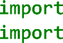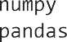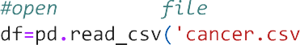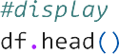



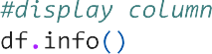



















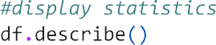





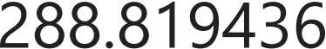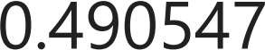





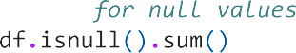



































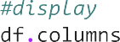







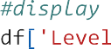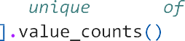











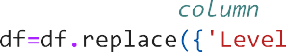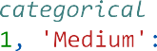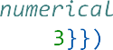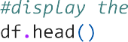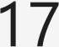



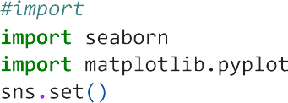



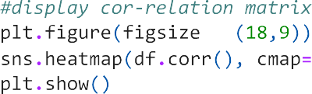

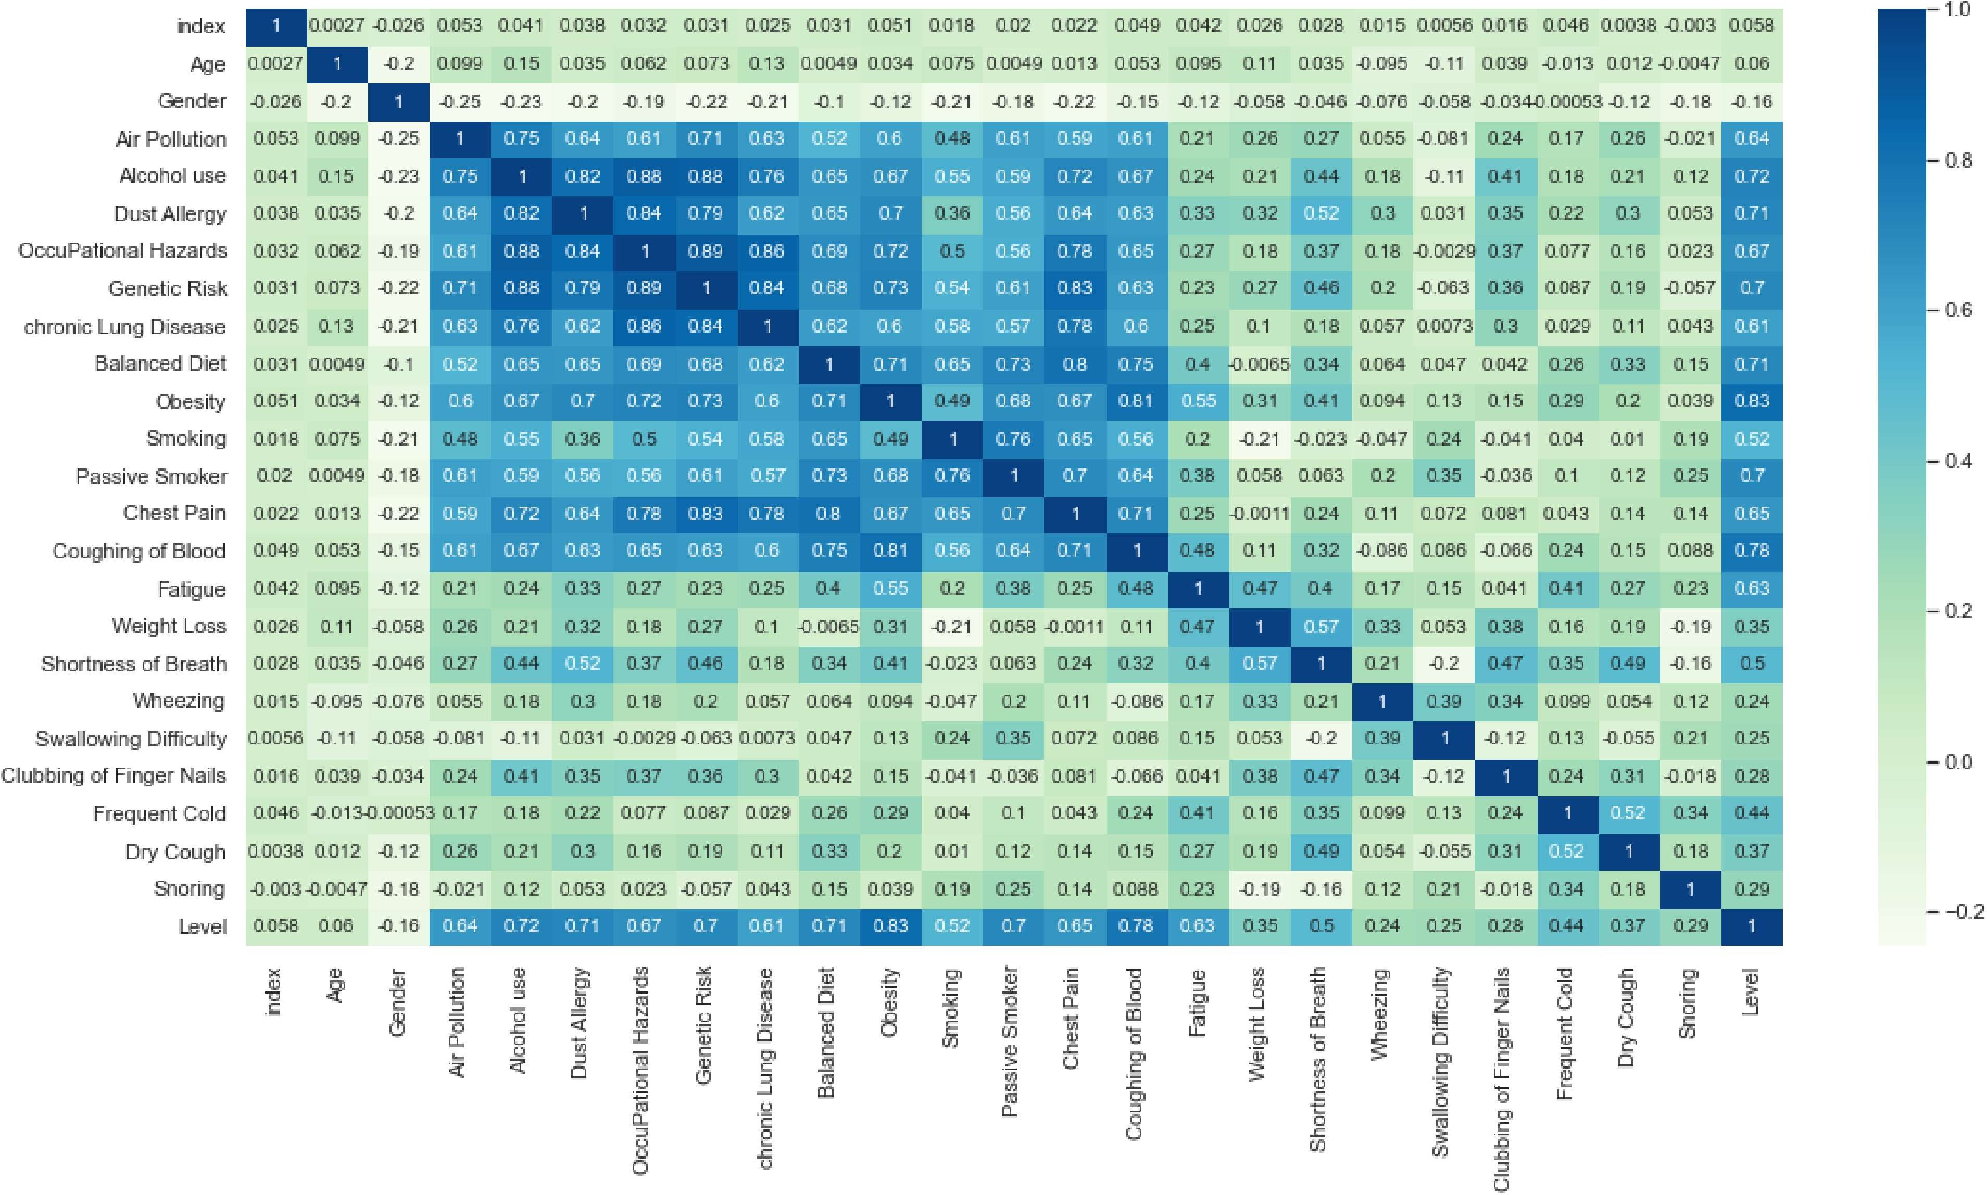

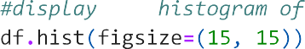





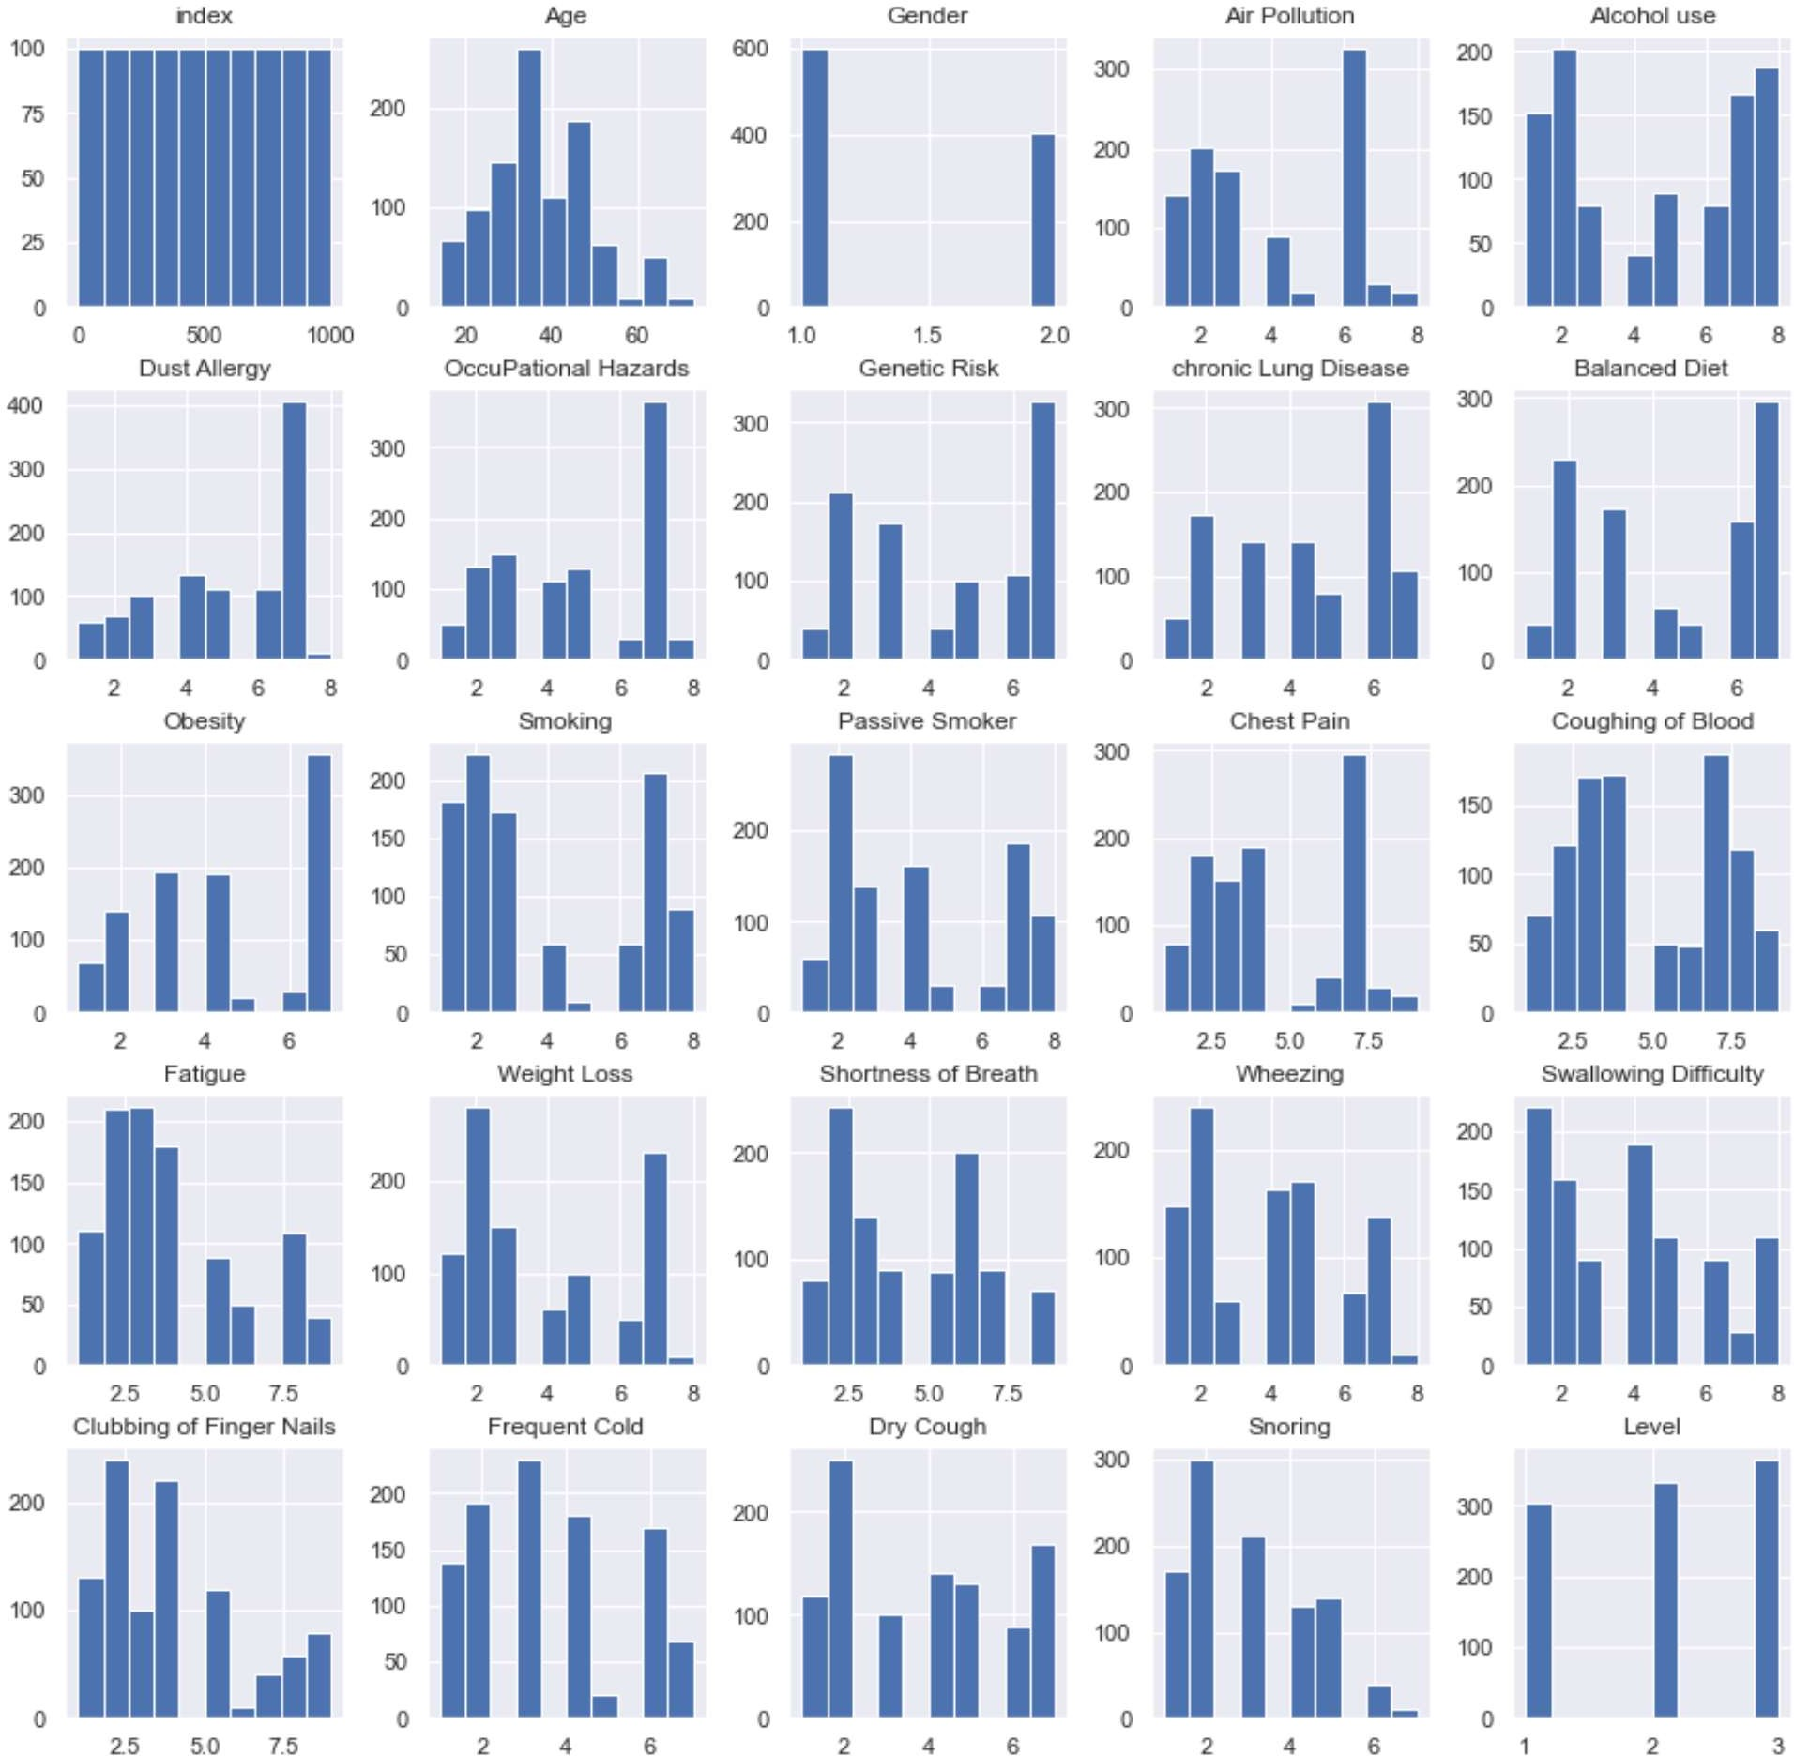



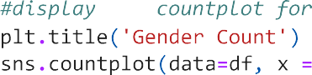

 

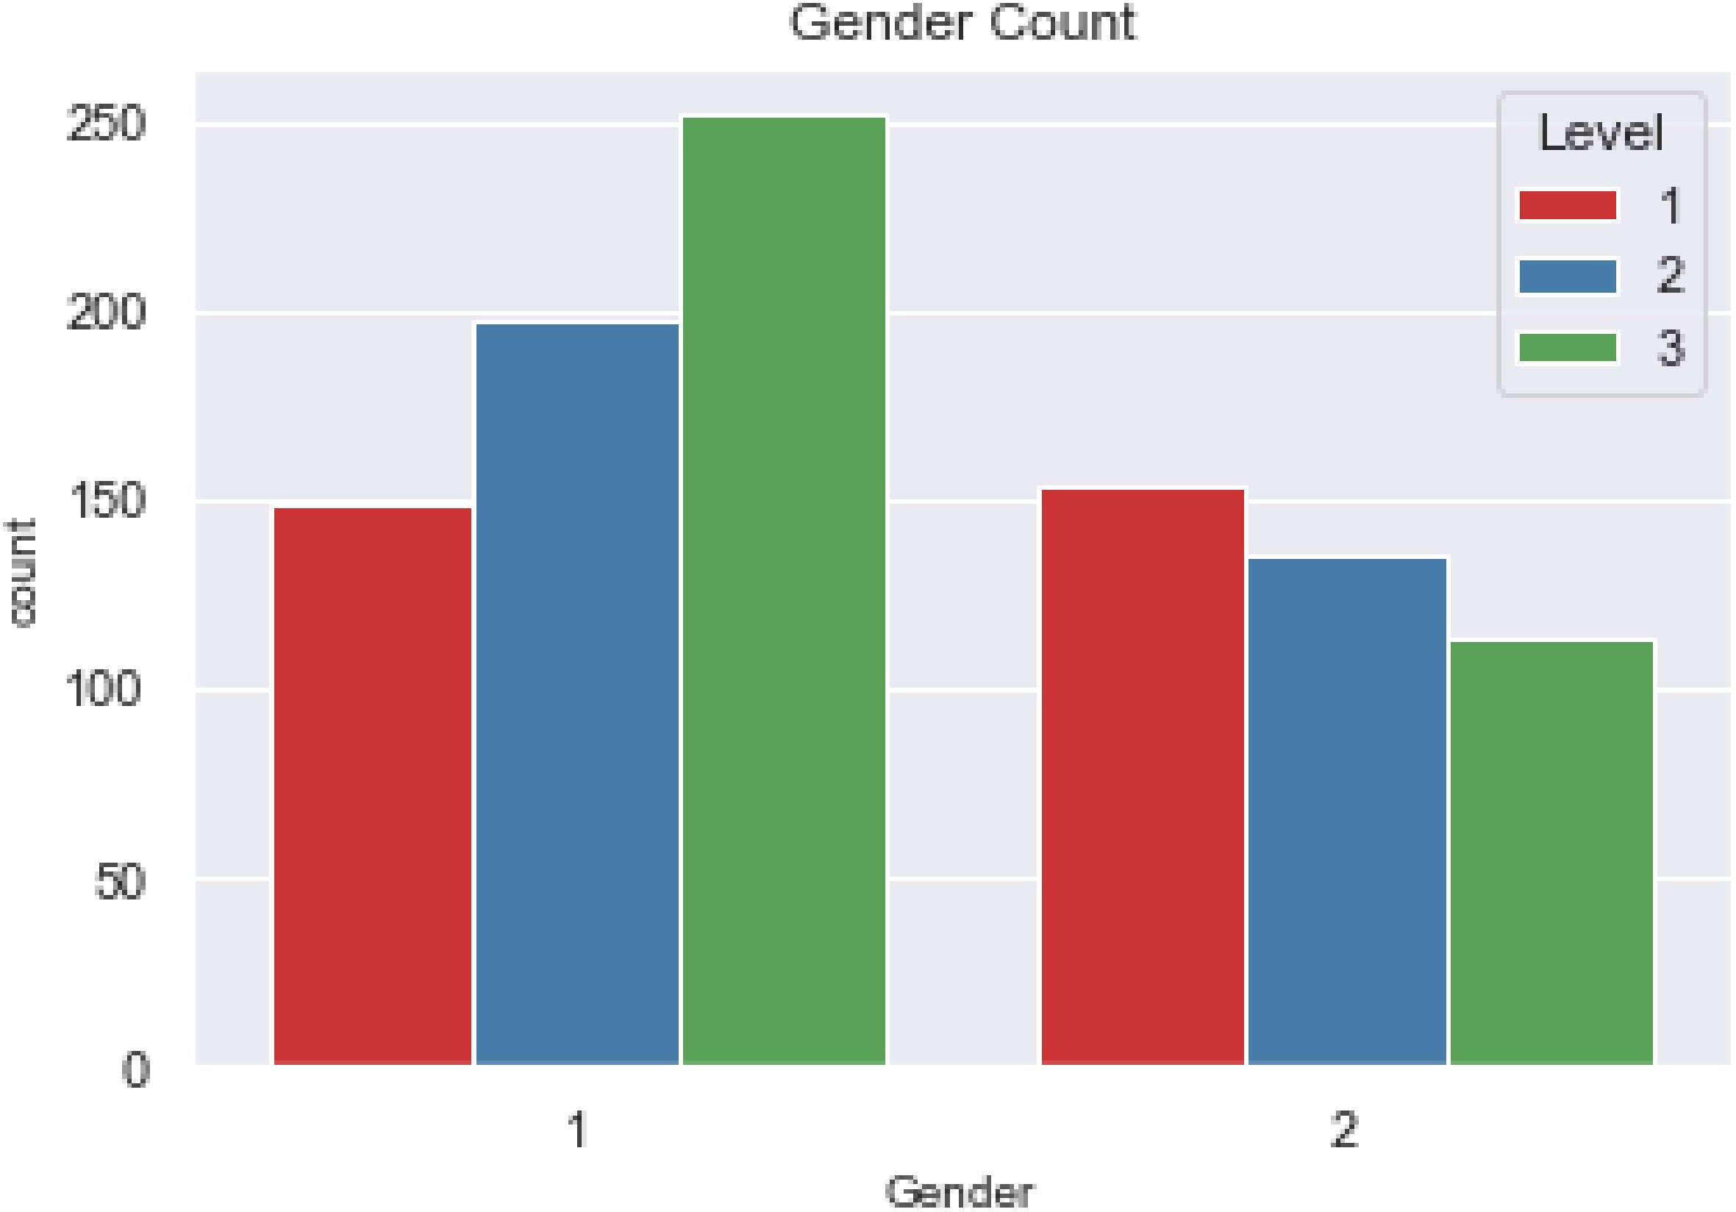



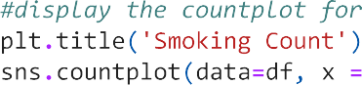

 

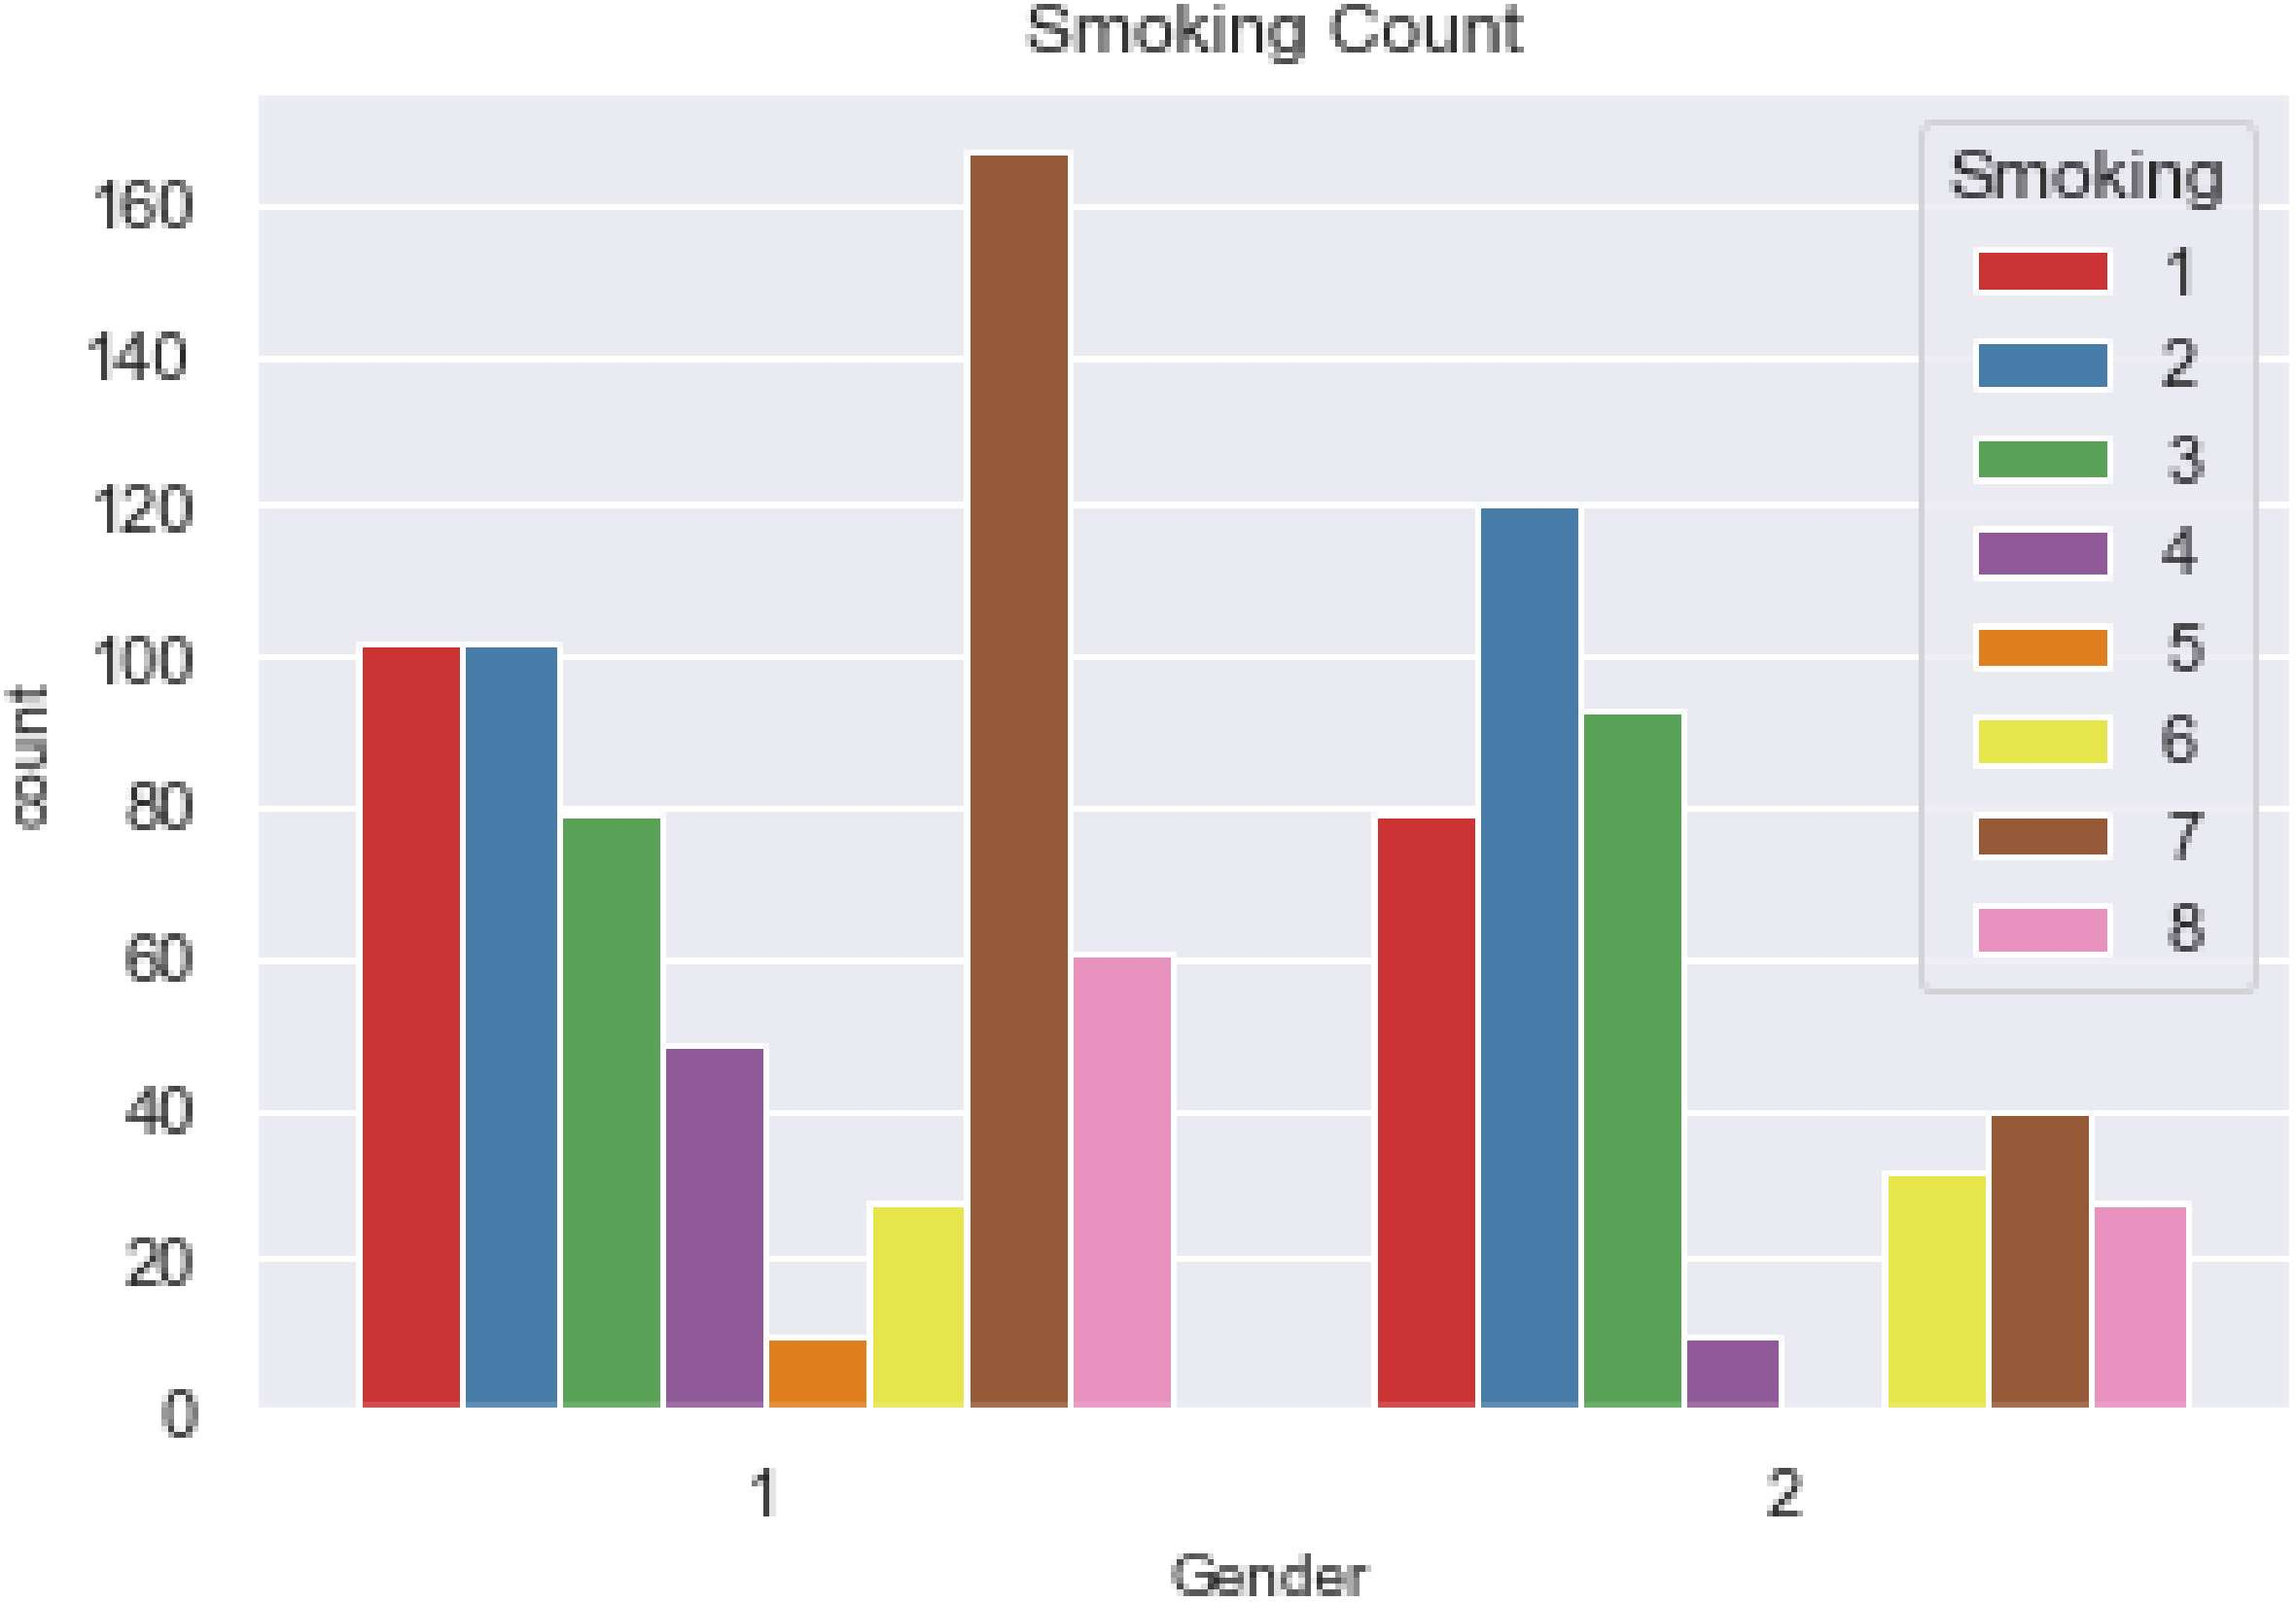



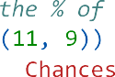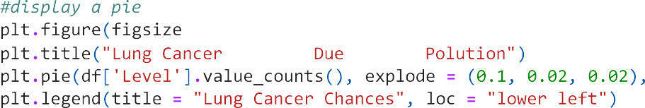

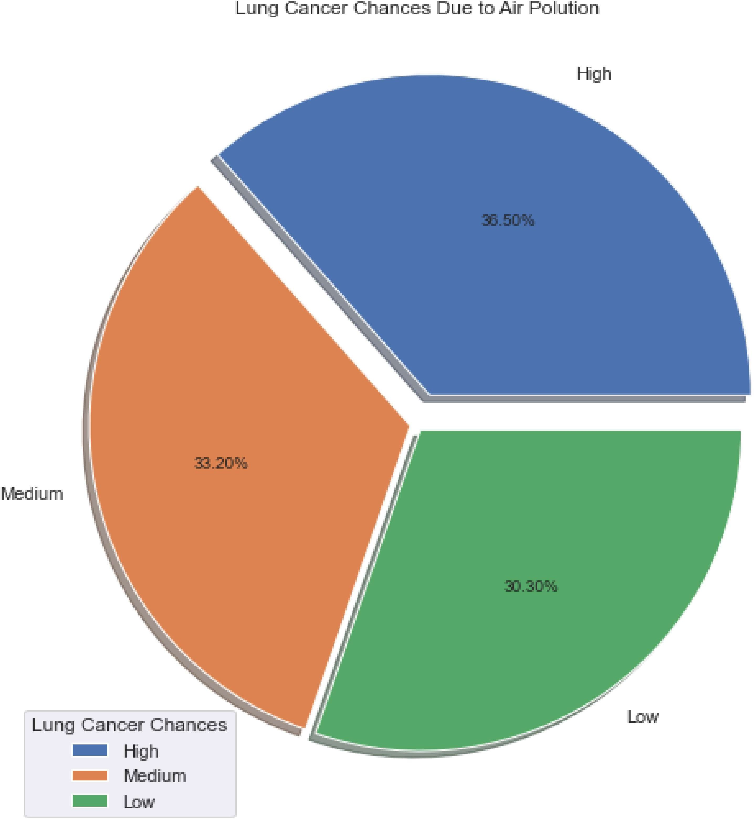



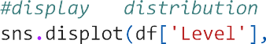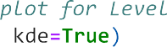

 

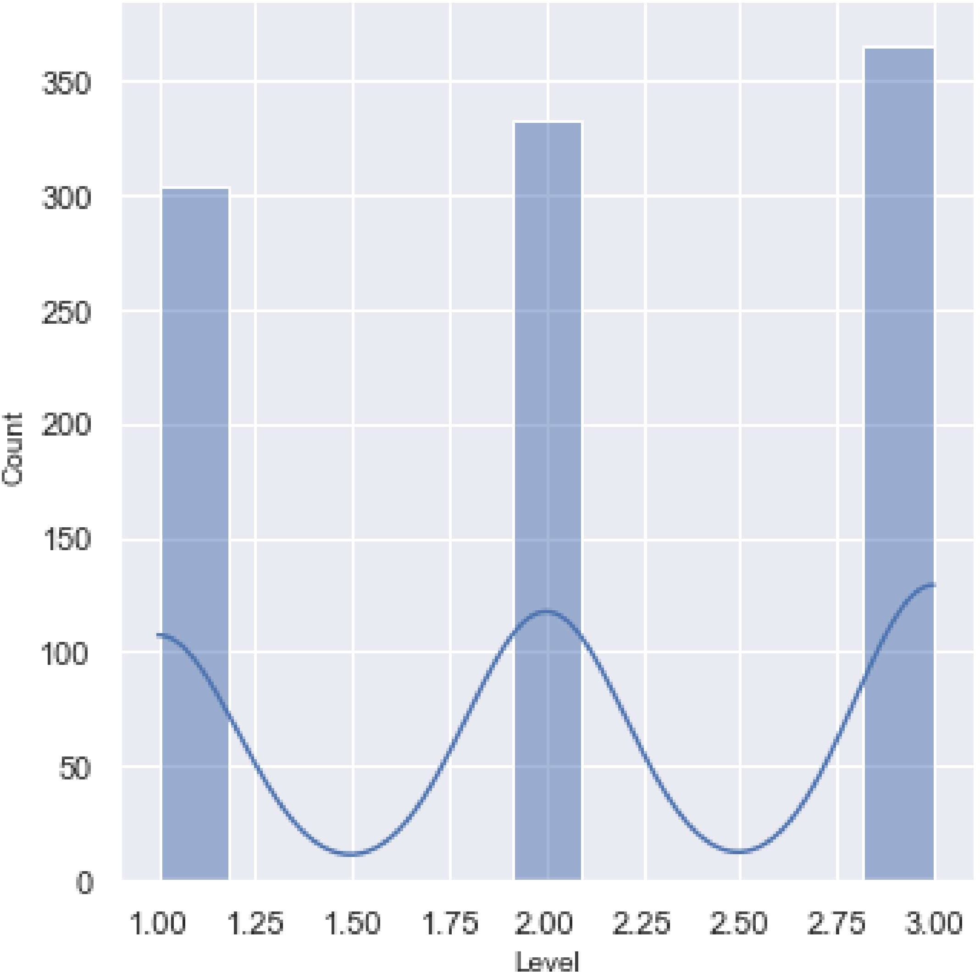



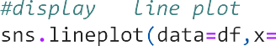

 

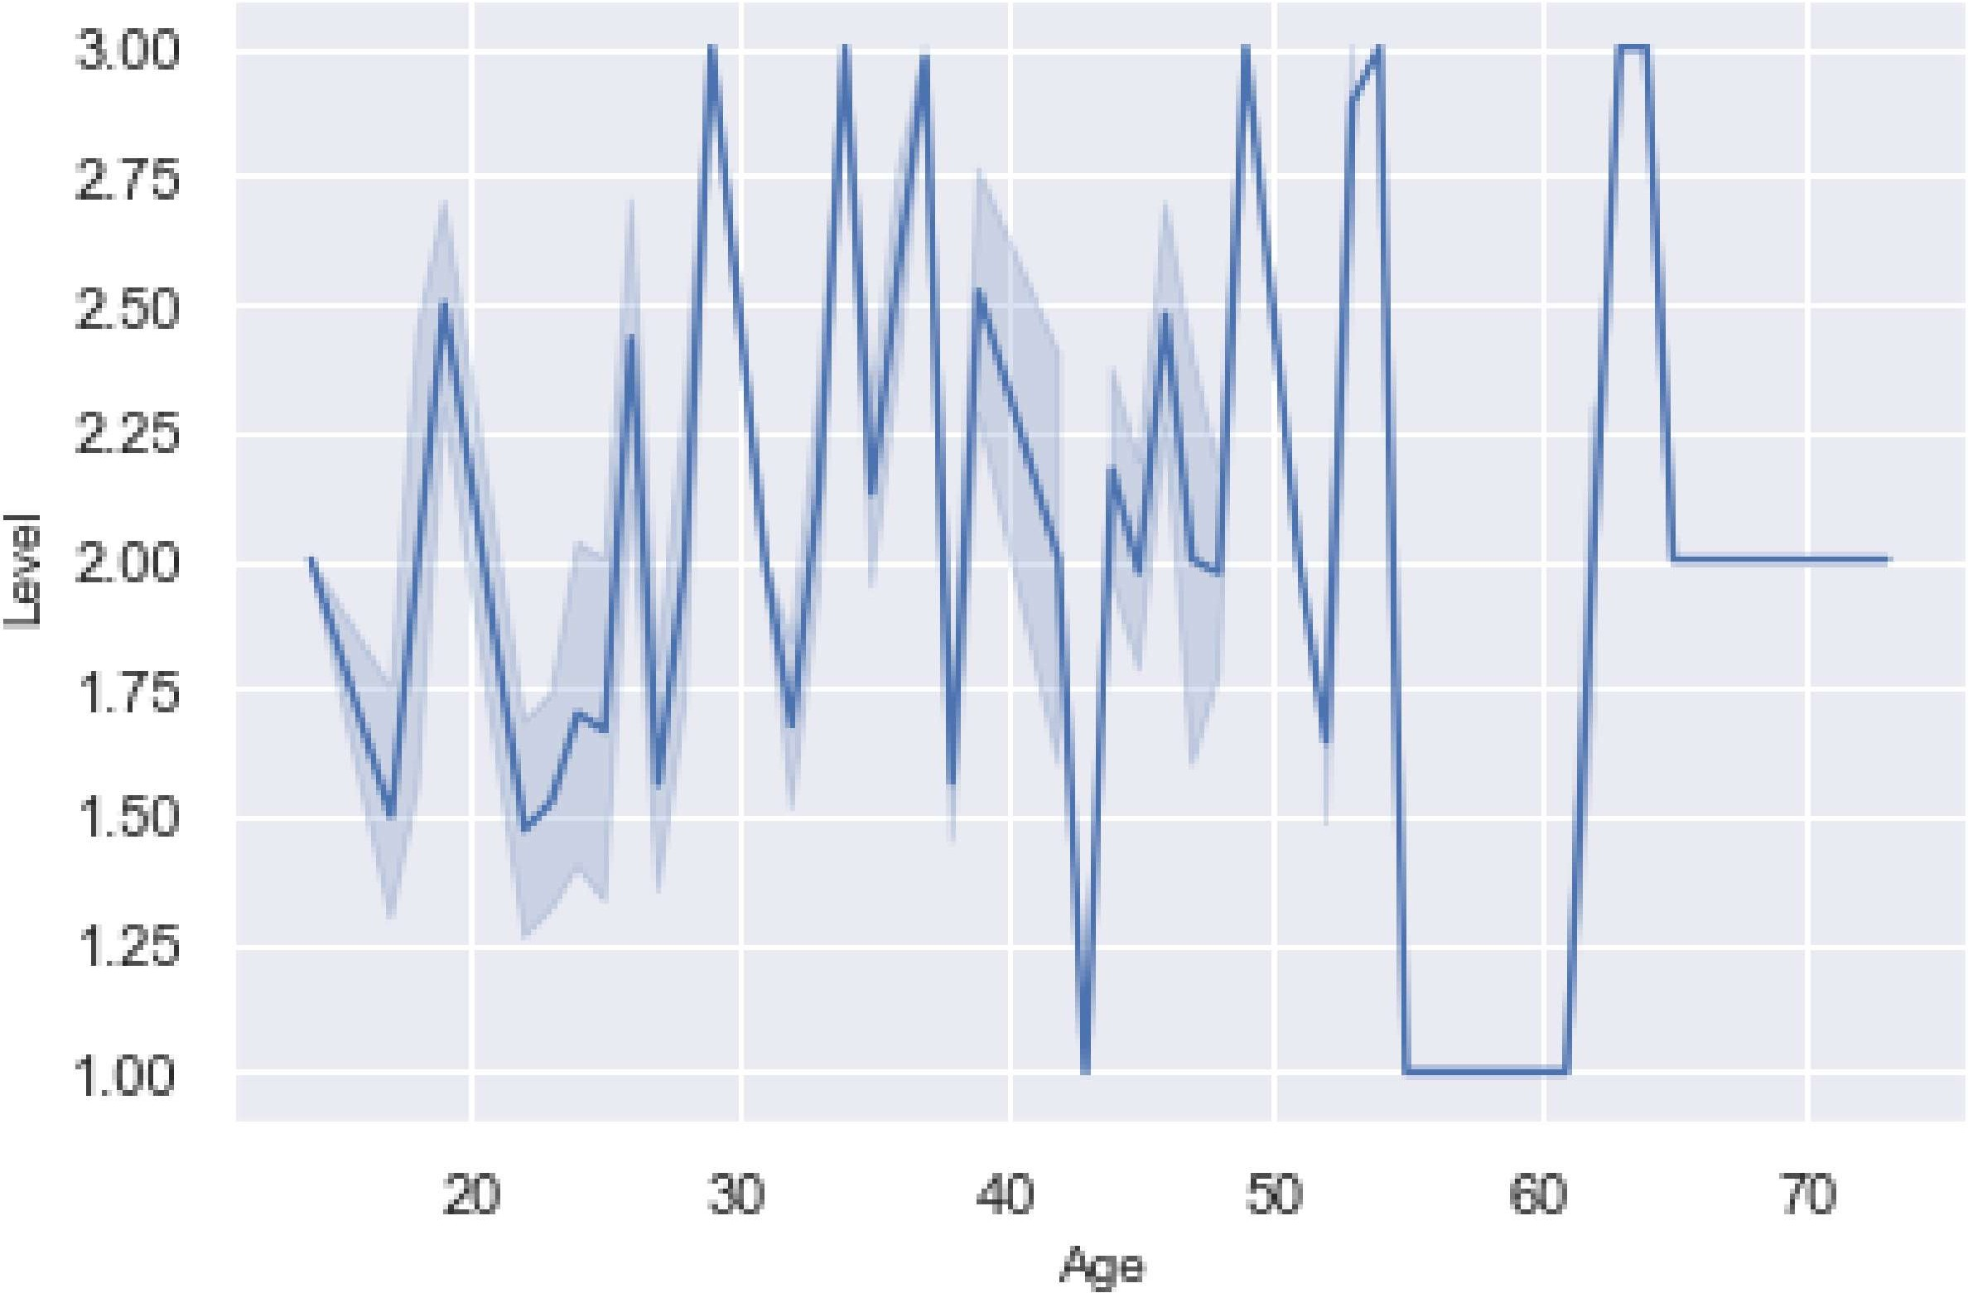

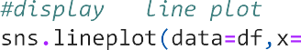



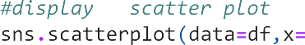

 

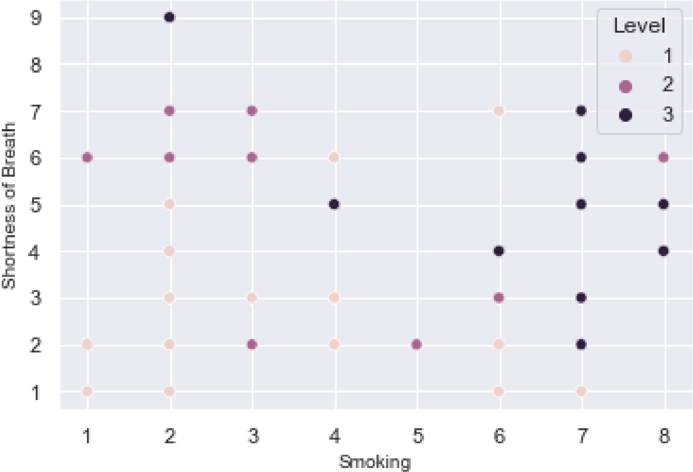

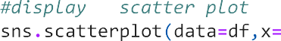

 







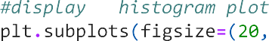

 

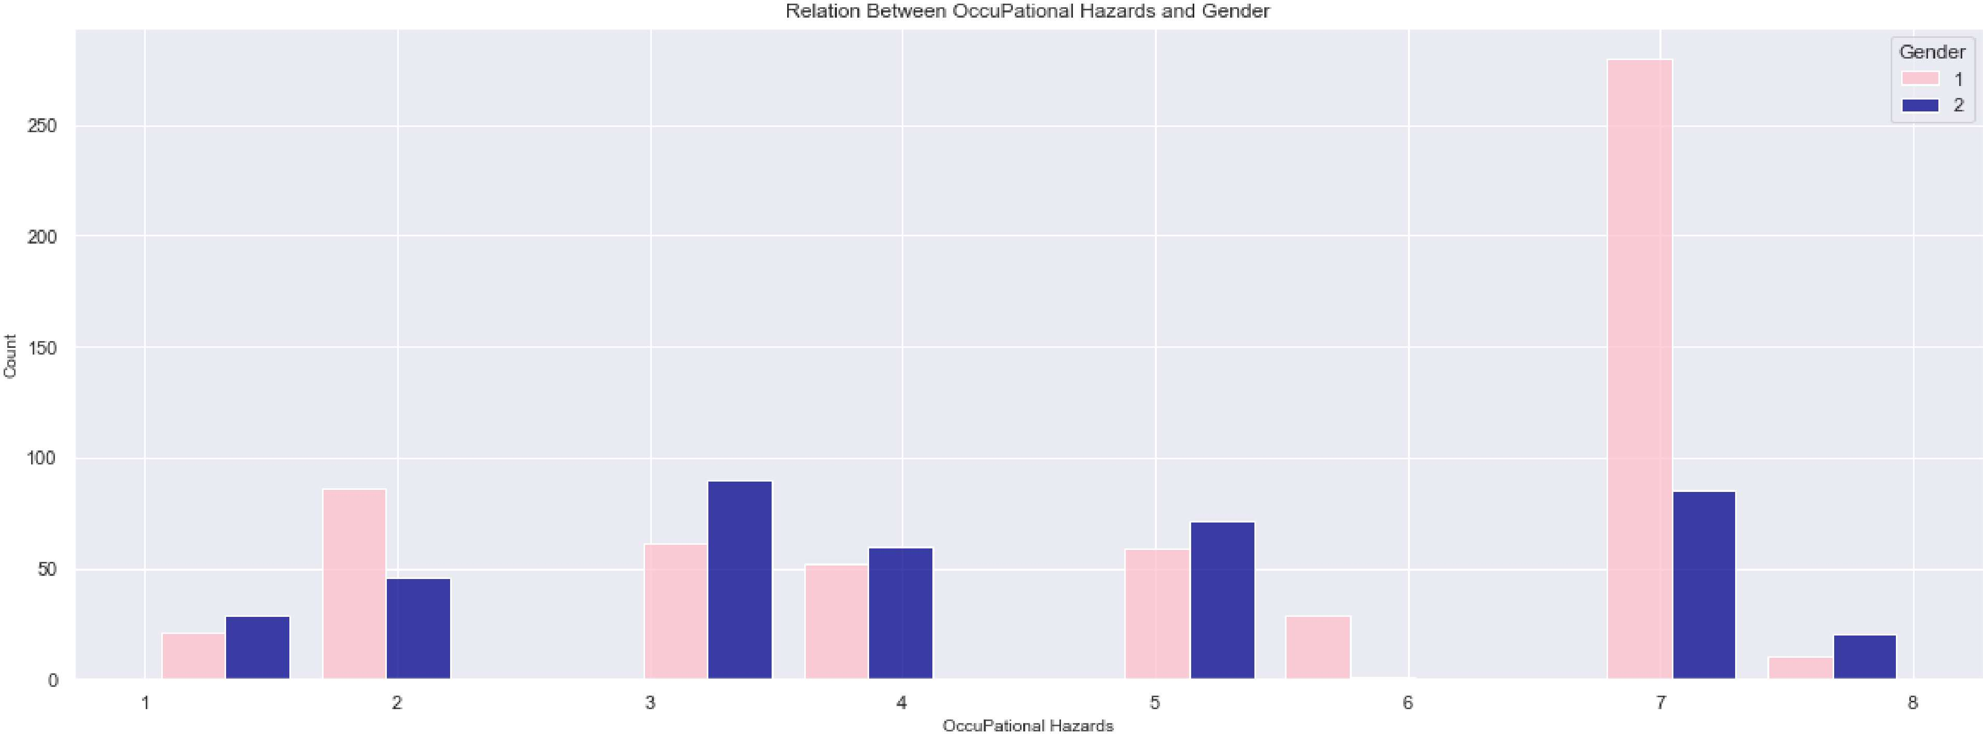

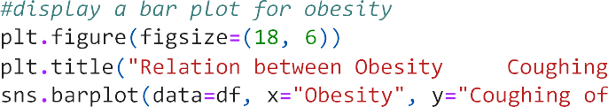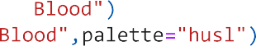

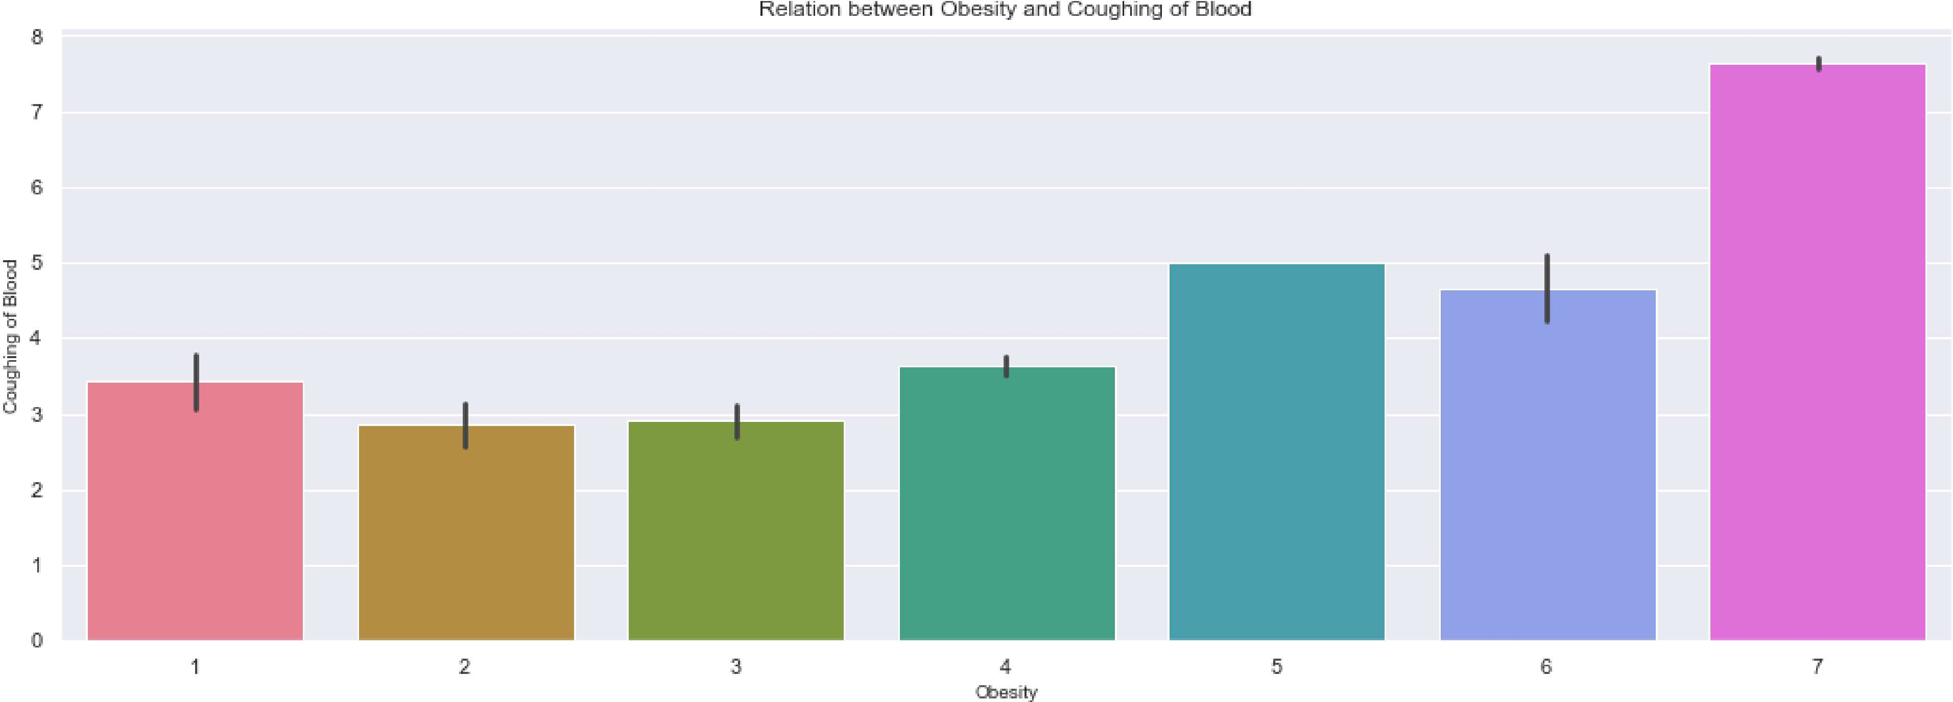





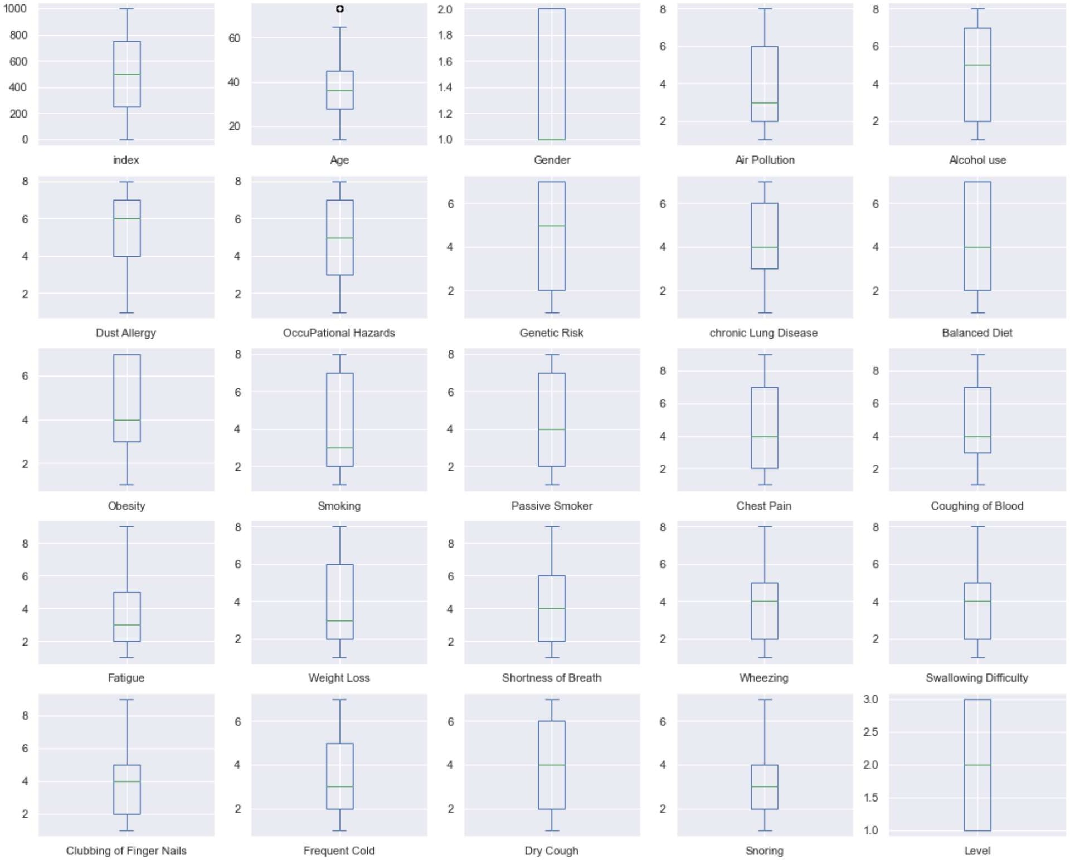



**Conclusion**

Through these data exploration and visualization techniques, we've gained valuable insights into the 'cancer.csv' dataset. These insights can inform further analysis, model building, or decision-making processes. Python libraries such as **numpy**, **pandas**, **seaborn**, and **matplotlib** proved to be powerful tools for data analysis and visualization.

This inference document summarizes the data analysis steps performed in your code and their significance in understanding the dataset.